观点：独立工作的第一人称多数情况下也用we，有时候也会用I，或避免使用第一人称。

在理工科中，独立工作大多都是提出抽象理论。Nature和Science的含金量极高，一般情况下，一篇论文会跟一大堆作者，项目负责人和做实验的学生都会在上面。Science期刊有News，Essay区有时由一个人撰写，但不能确定设计的工作是否是一个人完成的，而且News, Essay可能不能完全认为是学术研究；学术研究会在Research区发表，但这里的论文基本上都是一大堆人一块儿完成。Nature上面论文基本上全是团队工作。

最后列出来提出物理学界或计算机学界奠基性理论的四篇论文，均为个人独立工作，并分析人称。

# Science最近期刊

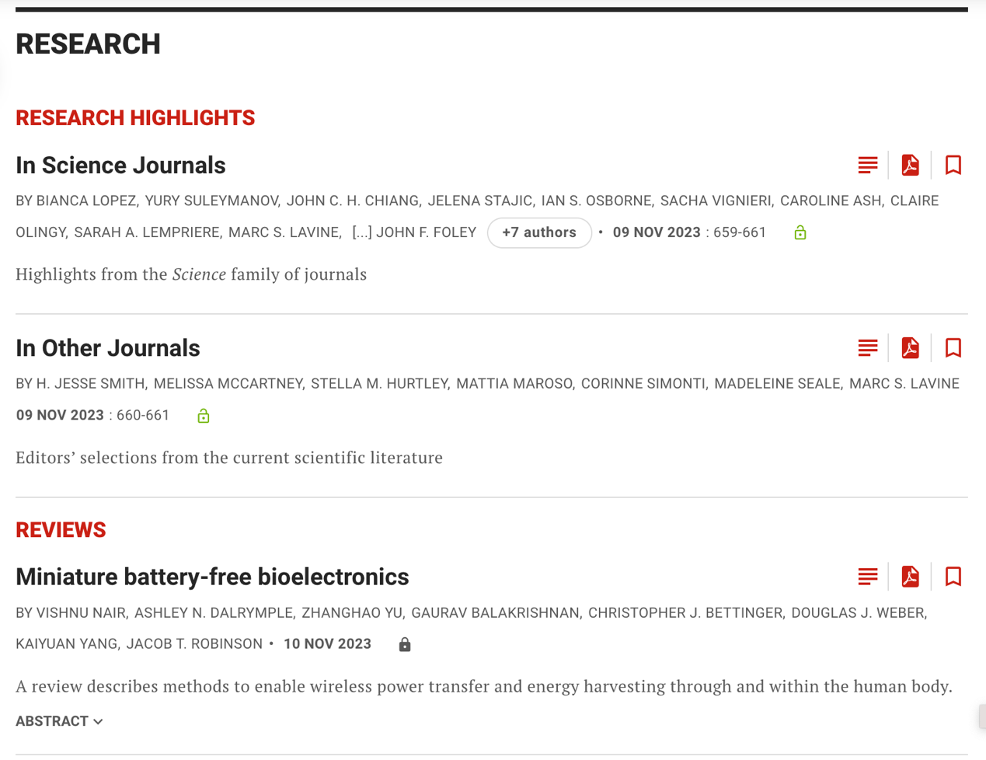

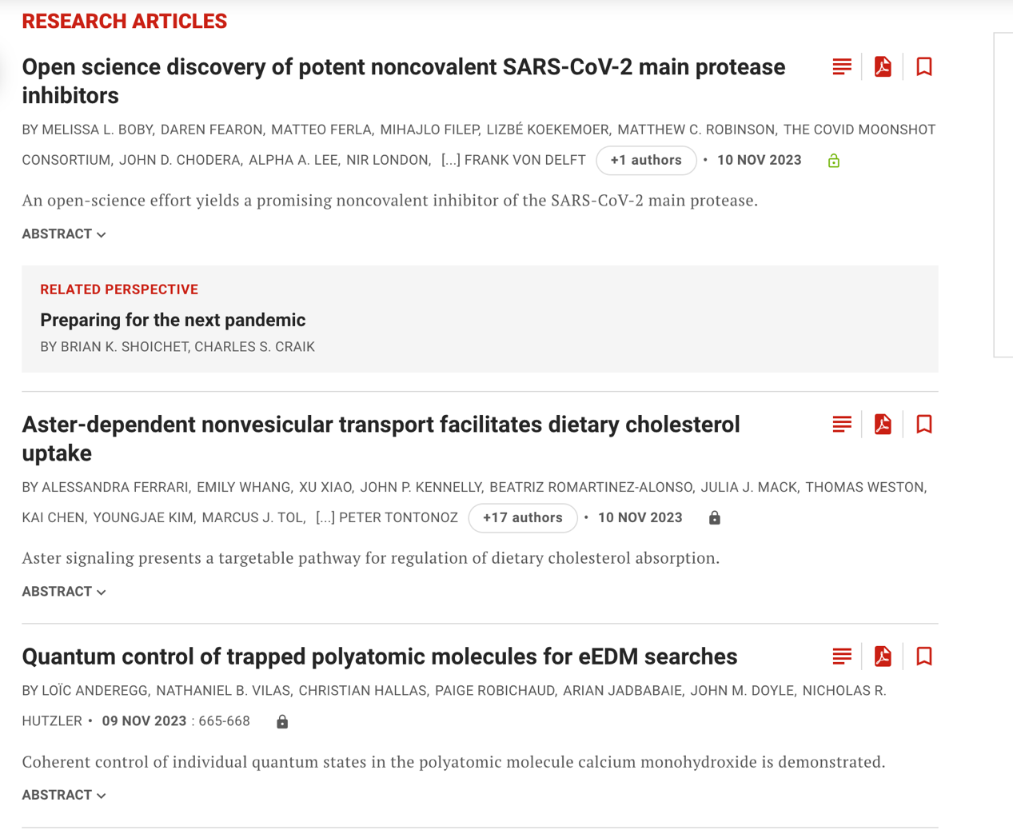

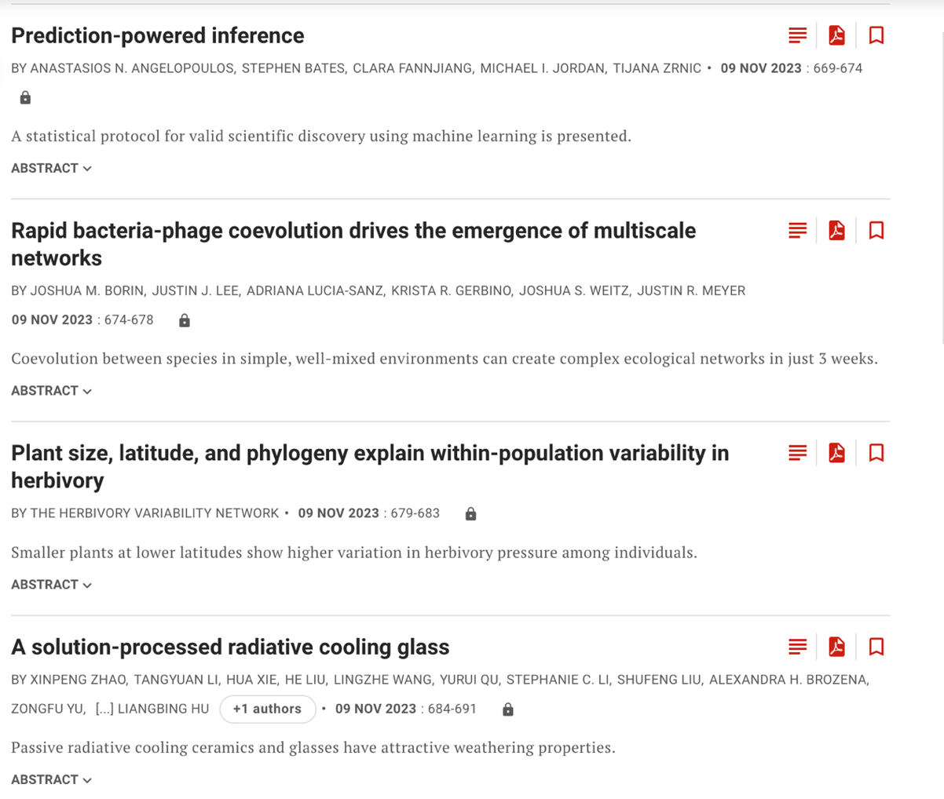



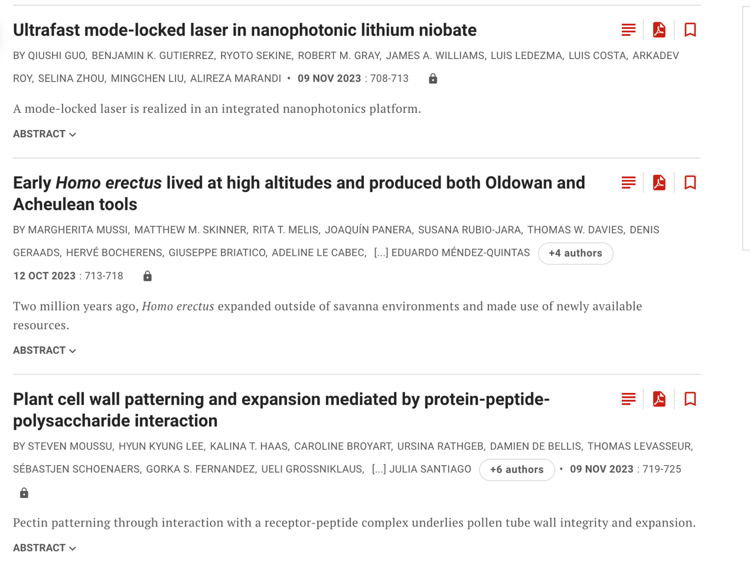



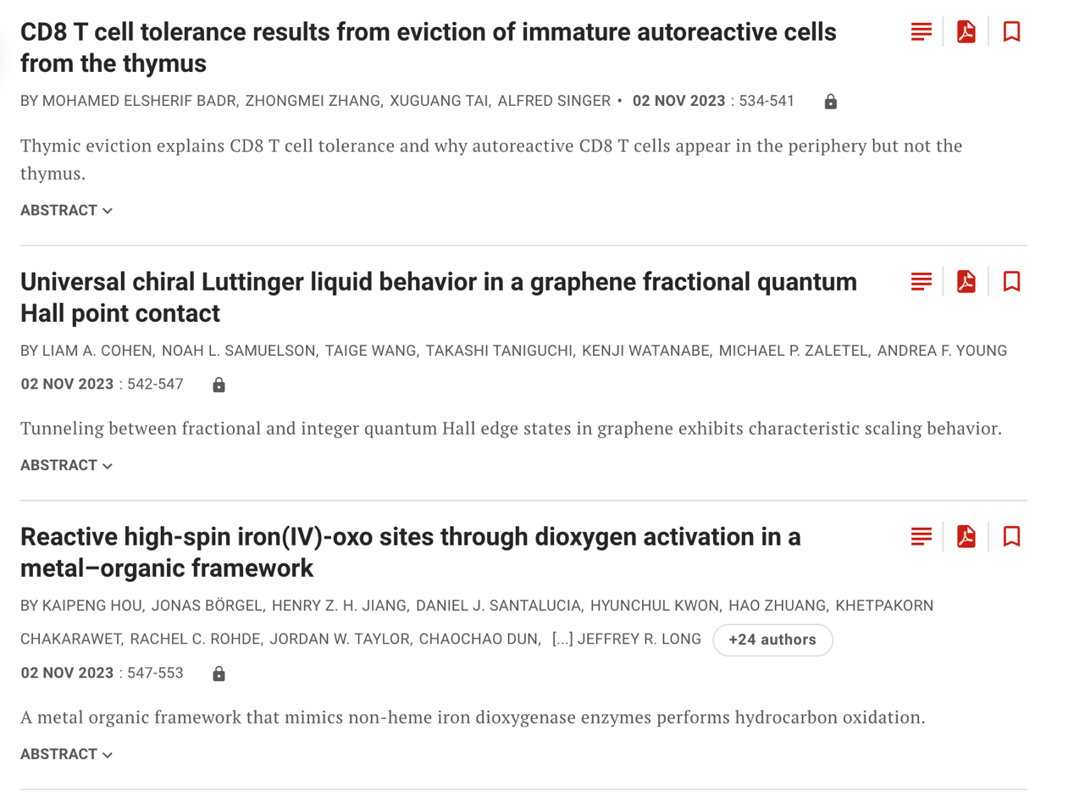

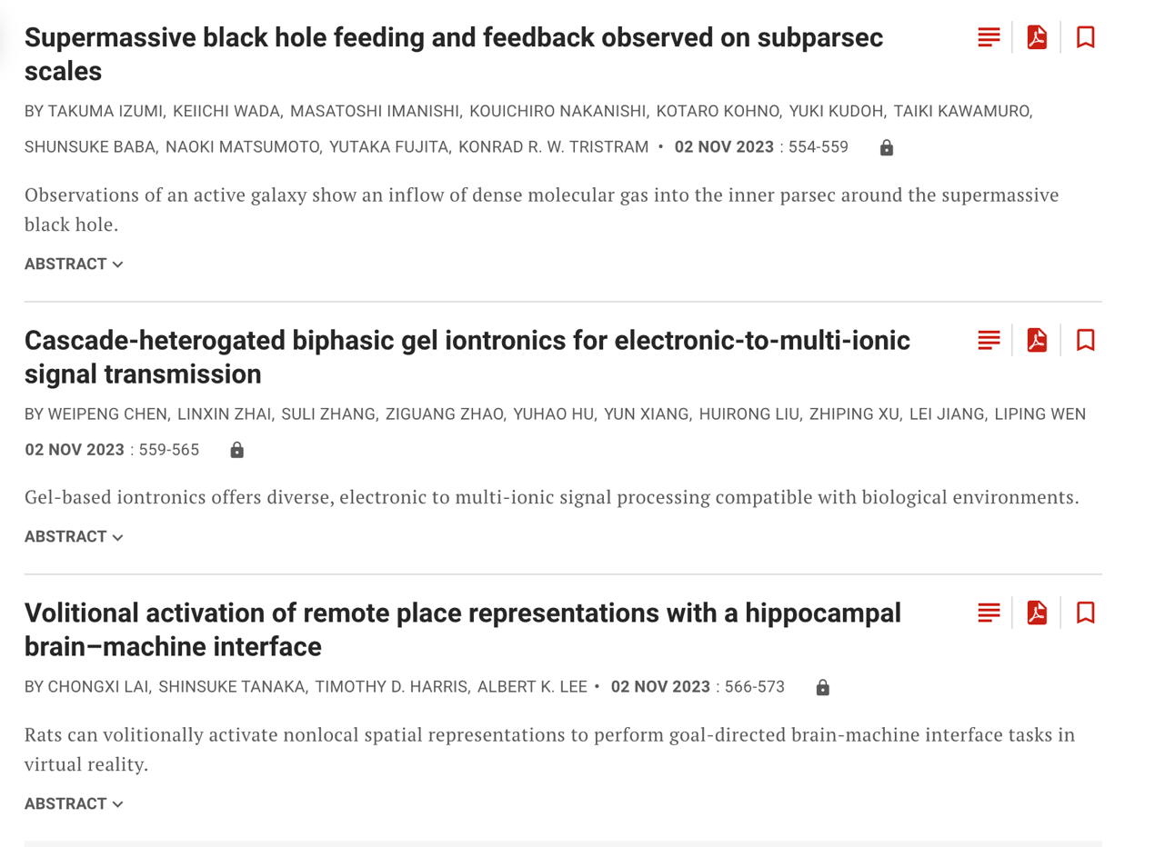

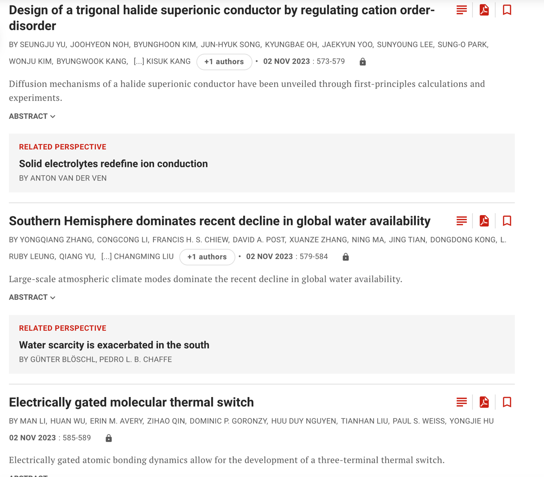



**可以看到Science期刊全部是团队工作。**

# Nature最近期刊

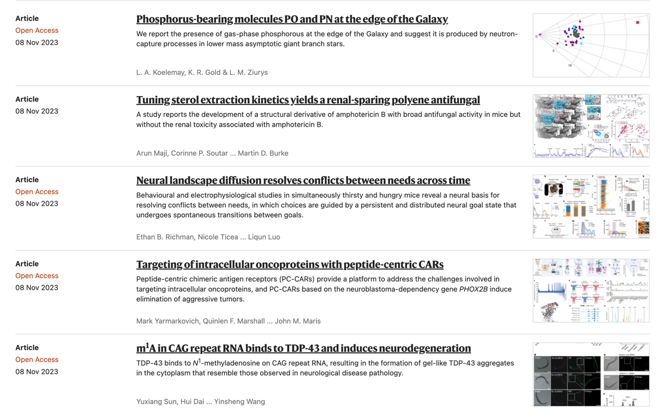

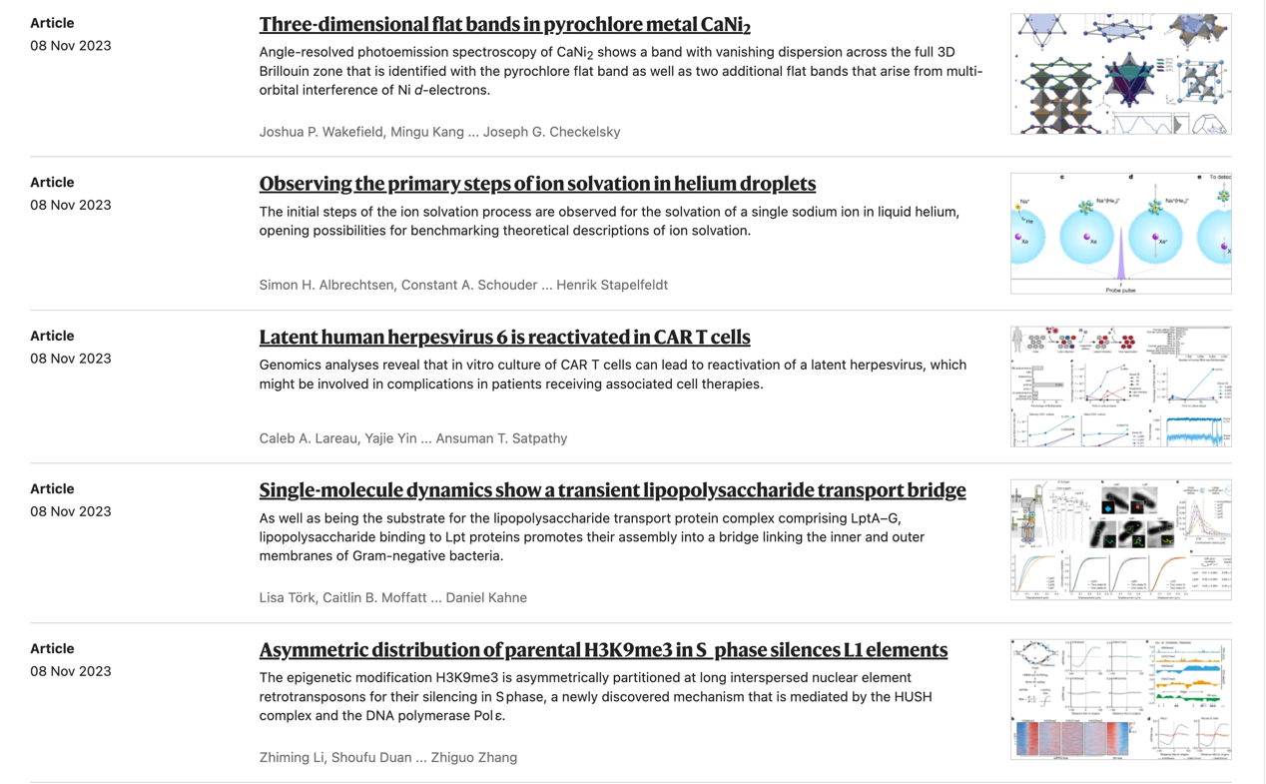

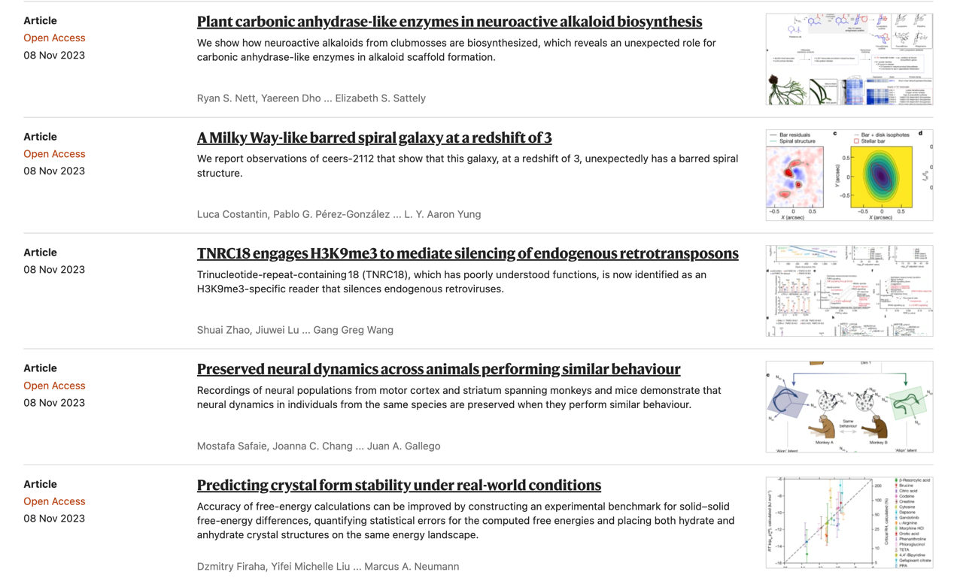

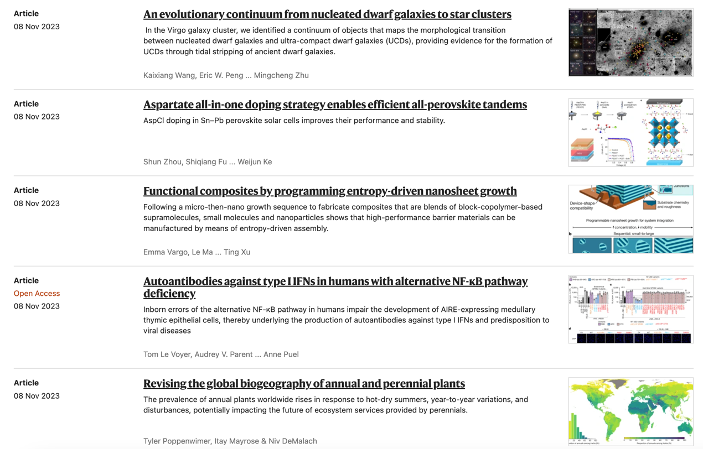



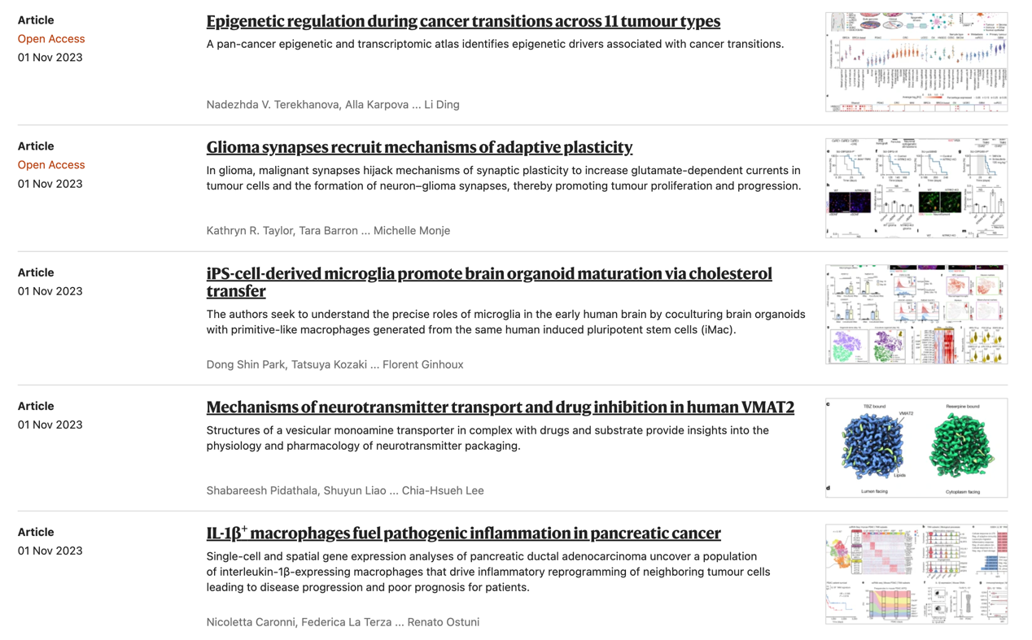

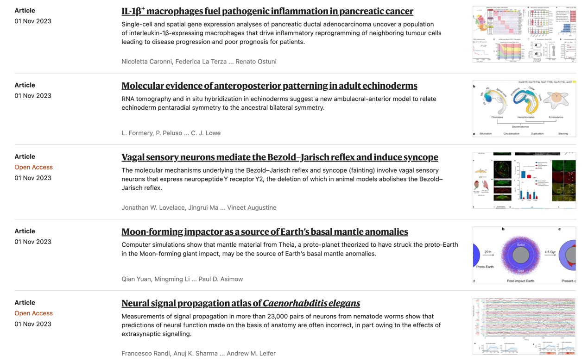

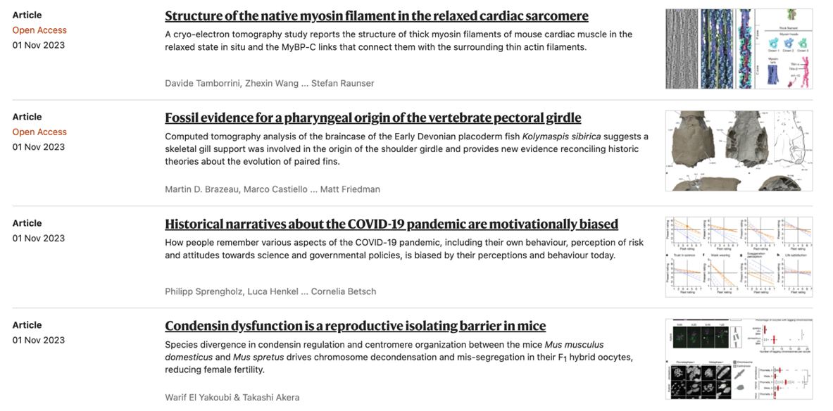



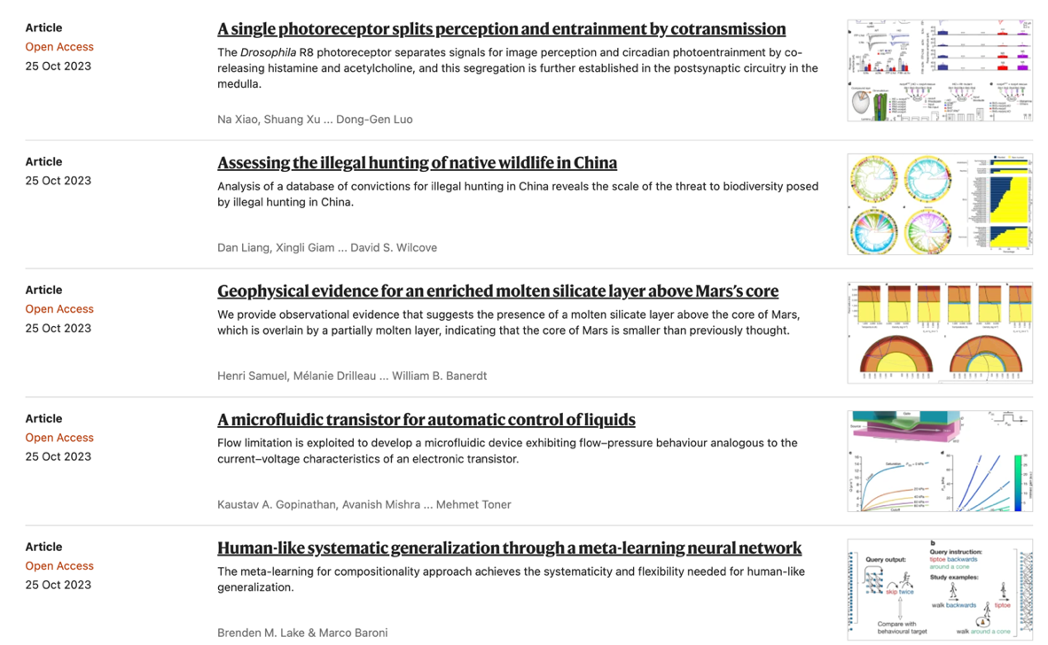

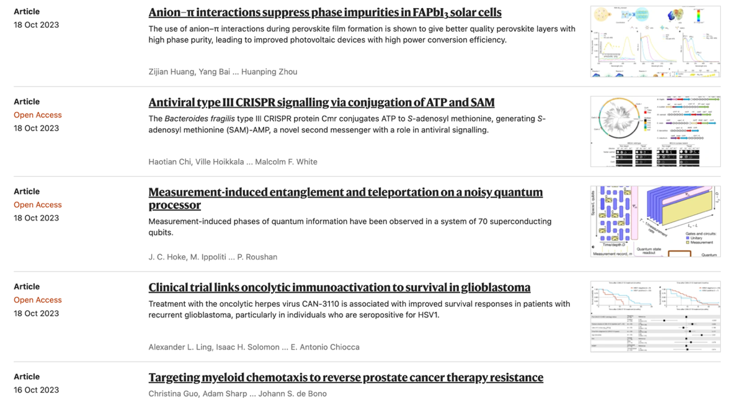

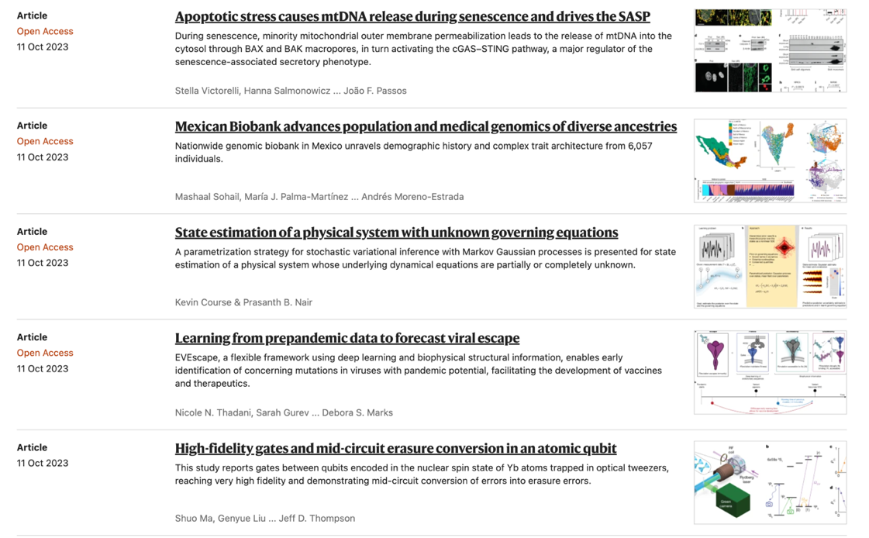

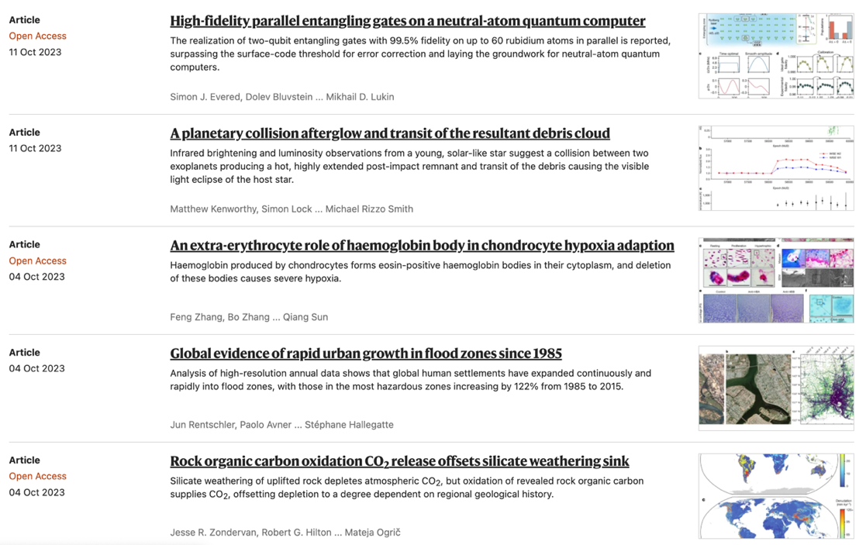

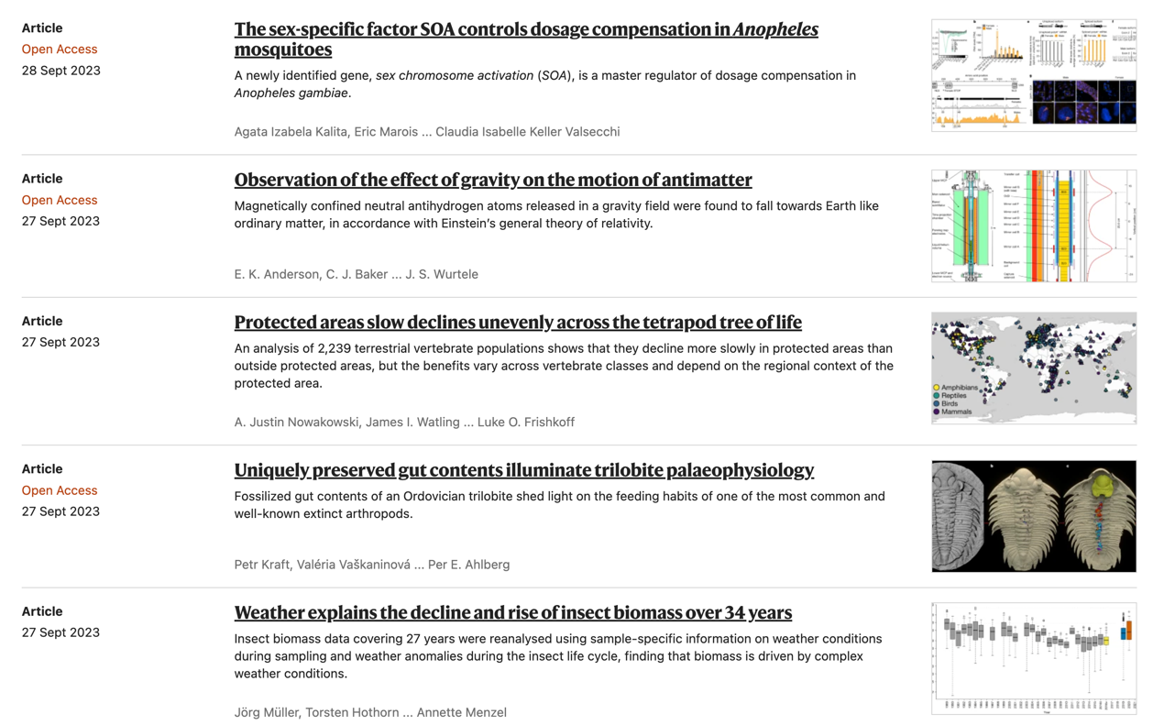

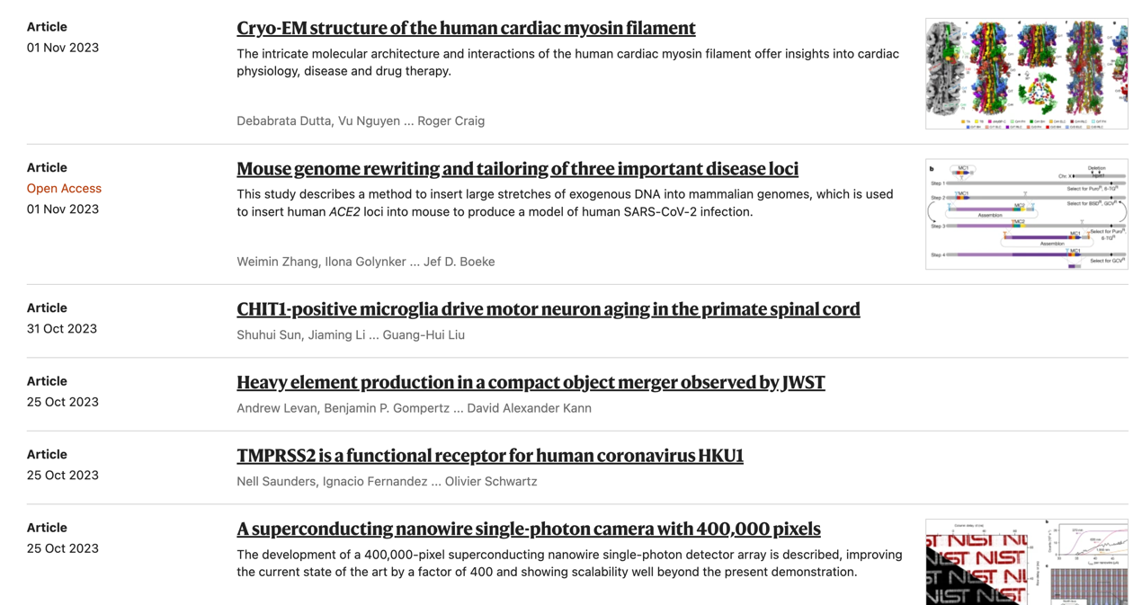

**可以看到Nature期刊全部是团队工作。**

# 其他期刊

很有意思的是，很多极为重大的、具有开拓性的理论既不是发表在Nature, Science上，也不是发表在CCF-A上面，反而是一些不是那么知名的期刊上面，或者是个人发表的专著，甚至只是一篇博士论文。比如物理学的物质波（德布罗意波）最早只是一篇博士毕业论文，但是却在5年后获得了诺贝尔奖。

## 物质波

### On the Theory of Quanta

**作者：Louis-Victor de Broglie**

（博士毕业论文，作者因此项工作在5年后获得了诺贝尔奖，所提出来的物质波也上了中学物理课本）

Introduction: History shows that there long has been dispute over two viewpoints on the nature of light: corpuscular and undulatory; perhaps however, these two are less at odds with each other than heretofore thought, which is a development that quantum theory is beginning to support.

Based on an understanding of the relationship between frequency and energy, **we proceed in this work from the assumption of existence of a certain periodic phenomenon of a yet to be determined character**, which is to be attributed to each and every isolated energy parcel, and from the PLANCK-EINSTEIN notion of proper mass, to a new theory. In addition, Relativity Theory requires that uniform motion of a material particle be associated with propagation of a certain wave for which the phase velocity is greater than that of light (Chapter 1).

For the purpose of generalizing this result to nonuniform motion, **we posit a proportionality between the momentum world vector of a particle and a propagation vector of a wave**, for which the fourth component is its frequency. Application of FERMAT’s Principle for this wave then is identical to the principle of least action applied to a material particle. Rays of this wave are identical to trajectories of a particle (CHAPTER 2).

The application of these ideas to the periodic motion of an electron in a BOHR atom leads then, to the stability conditions of a BOHR orbit being identical to the resonance condition of the associated wave (Chapter 3). This can then be applied to mutually inter- action electrons and protons of the hydrogen atoms (CHAPTER 4).

The further application of these general ideas to EINSTEIN’s notion of light quanta leads to several very interesting conclusions. In spite of remaining difficulties, there is good reason to hope that this approach can lead further to a quantum and undulatory theory of Optics that can be the basis for a statistical understanding of a relationship be- tween light-quanta waves and MAXWELL’s formulation of Electrodynamics (CHAPTER 5).

In particular, study of scattering of X and γ-rays by amorphous materials, reveals just how advantageous such a reformulation of electrodynamics would be (Chapter 6).

Finally, **we see how introduction of phase waves into Statistical Mechanics justifies the concept of existence of light quanta in the theory of gases and establishes**, given the laws of black body radiation, how energy parcellation between atoms of a gas and light quanta follows.

**可见作者使用第一人称复数we**

## 图灵机

### ON COMPUTABLE NUMBERS, WITH AN APPLICATION TO THE ENTSCHEIDUNGSPROBLEM

**作者：A. M. Turing**

（被誉为“计算机之父、人工智能之父”，这篇文章提出了图灵机，奠定了整个计算机学科的理论基础）

The “computable” numbers may be described briefly as the real numbers whose expressions as a decimal are calculable by finite means. Although the subject of this paper is ostensibly the computable numbers, it is almost equally easy to define and investigate computable functions of an integral variable or a real or computable variable, computable predicates, and so forth. The fundamental problems involved are, however, the same in each case, **and I have chosen the computable numbers for explicit treatment as involving the least cumbrous technique.** **I hope shortly to give an account of the relations of the computable numbers**, functions, and so forth to one another. This will include a development of the theory of functions of a real variable expressed in terms of computable numbers. According to my definition, a number is computable if its decimal can be written down by a machine.

In §§ 9, 10 **I give some arguments with the intention of showing that the computable numbers include all numbers which could naturally be regarded as computable**. In particular, **I show that certain large classes of numbers are computable**. They include, for instance, the real parts of all algebraic numbers, the real parts of the zeros of the Bessel functions, the numbers π, e, etc. The computable numbers do not, however, include all definable numbers, and an example is given of a definable number which is not computable.

Although the class of computable numbers is so great, and in many ways similar to the class of real numbers, it is nevertheless enumerable. In §8 **I examine certain arguments which would seem to prove the contrary**. By the correct application of one of these arguments, conclusions are reached which are superficially similar to those of Gödel [1] . These results {231} have valuable applications. In particular, it is shown (§11) that the Hilbertian Entscheidungsproblem can have no solution.

In a recent paper Alonzo Church[2] has introduced an idea of “effective calculability”, which is equivalent to my “computability”, but is very differently defined. Church also reaches similar conclusions about the Entscheidungsproblem.[3] The proof of equivalence between “computability” and “effective calculability” is outlined in an appendix to the present paper.

**Entscheidungsproblem的意思是“决策问题”。**

**作者使用I当做第一人称。**

## 比特币

### Bitcoin: A Peer-to-Peer Electronic Cash System

**作者：Satoshi Nakamoto**

（神秘人物，至今不知道是谁，但比特币改变了整个世界，催生了区块链，甚至促进了数字人民币的诞生）

摘要：

A purely peer-to-peer version of electronic cash would allow online payments to be sent directly from one party to another without going through a financial institution. Digital signatures provide part of the solution, but the main benefits are lost if a trusted third party is still required to prevent double-spending. **We propose a solution to the double-spending problem using a peer-to-peer network.** The network timestamps transactions by hashing them into an ongoing chain of hash-based proof-of-work, forming a record that cannot be changed without redoing the proof-of-work. The longest chain not only serves as proof of the sequence of events witnessed, but proof that it came from the largest pool of CPU power. As long as a majority of CPU power is controlled by nodes that are not cooperating to attack the network, they'll generate the longest chain and outpace attackers. The network itself requires minimal structure. Messages are broadcast on a best effort basis, and nodes can leave and rejoin the network at will, accepting the longest proof-of-work chain as proof of what happened while they were gone.

**使用了we作为第一人称，虽然据推测工作是一个人完成的。**

## 深度学习

### Training Products of Experts by Minimizing Contrastive Divergence

**作者：Geoffrey E. Hinton**

（被誉为“深度学习之父”）

摘要：It is possible to combine multiple latent-variable models of the same data by multiplying their probability distributions together and then renormalizing. This way of combining individual “expert” models makes it hard to generate samples from the combined model but easy to infer the values of the latent variables of each expert, because the combination rule ensures that the latent variables of different experts are conditionally in- dependent when given the data. A product of experts (PoE) is therefore an interesting candidate for a perceptual system in which rapid inference is vital and generation is unnecessary. Training a PoE by maximizing the likelihood of the data is difficult because it is hard even to approximate the derivatives of the renormalization term in the combination rule. Fortunately, a PoE can be trained using a different objective function called “contrastive divergence” whose derivatives with regard to the parameters can be approximated accurately and efficiently. Examples are presented of contrastive divergence learning using several types of expert on several types of data.

**可以看出，这篇论文在避免使用第一人称，比如会用被动语态。**